Zachary Chance

Dr. Cunningham

Causal Inference

5/20/2020

**Causal Inference Assignment 3: Randomization Inference with Regression**

1. Done. Github link is at:
   1. https://github.com/zachary-chance1/CI-Assignment-3.git
2. Done. Changes made were as nonintrusive as possible, so most changed code is just commented out.
3. Under 100 iterations, *p* = .01. Under 1000 iterations, *p =* .001. Under 10,000 iterations, *p =* .0001. Each value is stored as p_value_# of iterations.
4. Done. Find it in the Figures subdirectory or pasted below:

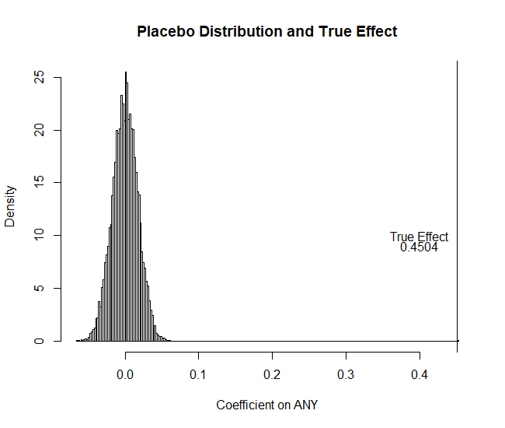

1. The approximate probability that the distribution came from the placebo distribution is .0001, the *p*-value. It represents the probability that the observed outcome is due to random chance, i.e. that it was generated under the assumption of no treatment effect. In this case, that value is .0001.